**Step1: Launching**

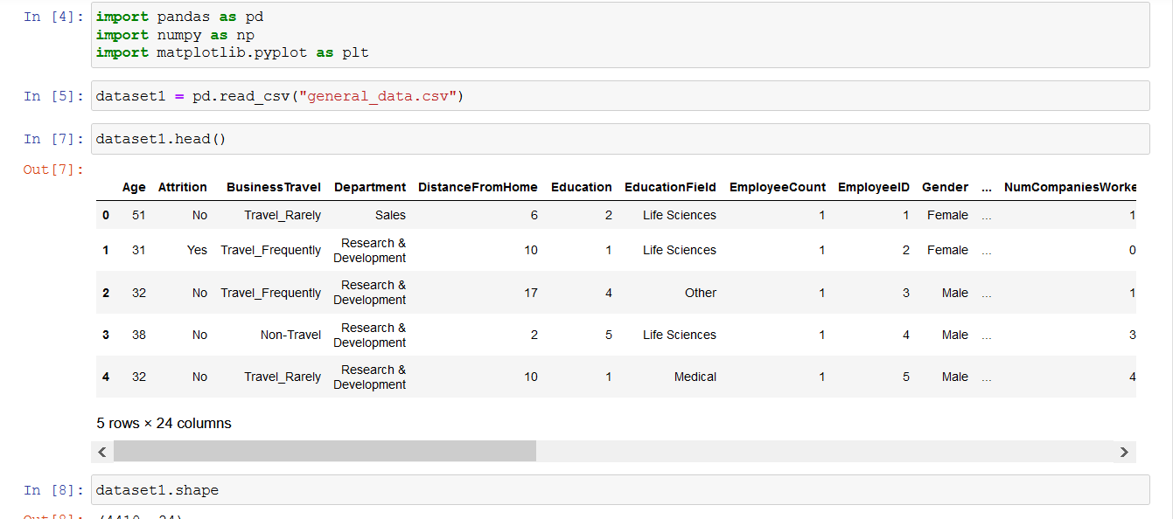

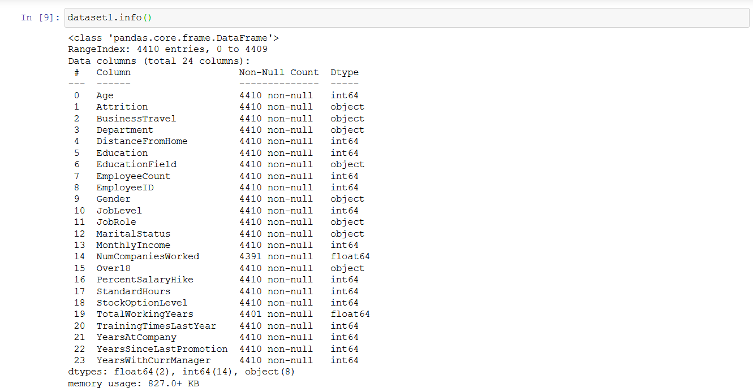

**Step 2 : Data Treatment**

1. Remove the null values and remove the duplicate values.

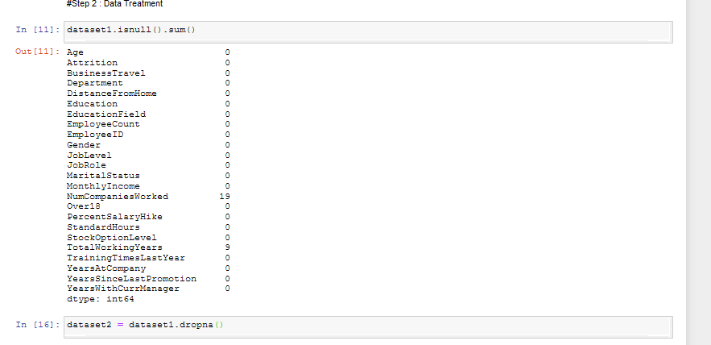

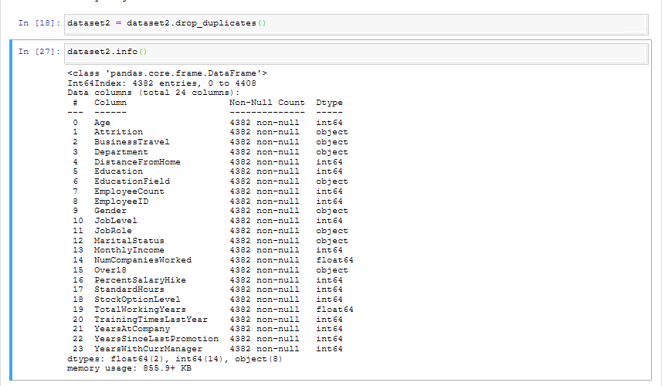

**Step 3 : Univariate Analysis**



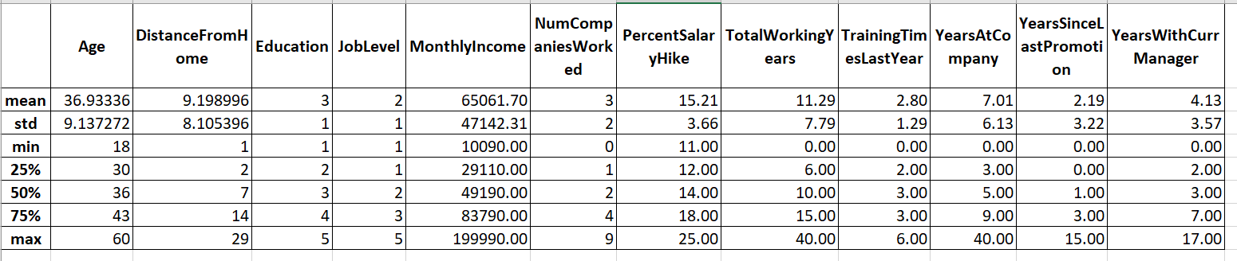

**Observations :**

dataset2[['Age','DistanceFromHome','Education','MonthlyIncome','NumCompaniesWorked','PercentSalaryHike','TotalWorkingYears','TrainingTimesLastYear','YearsAtCompany','YearsSinceLastPromotion','YearsWithCurrManager']].median()

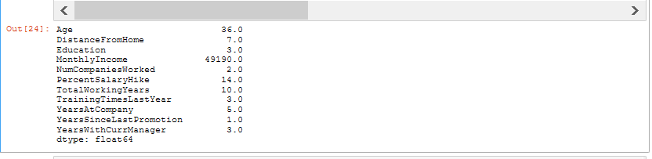

dataset2[['Age','DistanceFromHome','Education','MonthlyIncome','NumCompaniesWorked','PercentSalaryHike','TotalWorkingYears','TrainingTimesLastYear','YearsAtCompany','YearsSinceLastPromotion','YearsWithCurrManager']].mode()



dataset2[['Age','DistanceFromHome','Education','MonthlyIncome','NumCompaniesWorked','PercentSalaryHike','TotalWorkingYears','TrainingTimesLastYear','YearsAtCompany','YearsSinceLastPromotion','YearsWithCurrManager']].var()

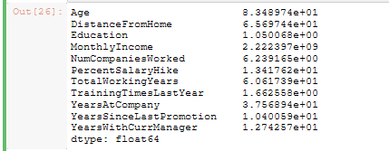

dataset2[['Age','DistanceFromHome','Education','MonthlyIncome','NumCompaniesWorked','PercentSalaryHike','TotalWorkingYears','TrainingTimesLastYear','YearsAtCompany','YearsSinceLastPromotion','YearsWithCurrManager']].kurt()

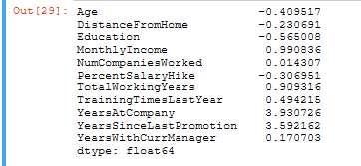

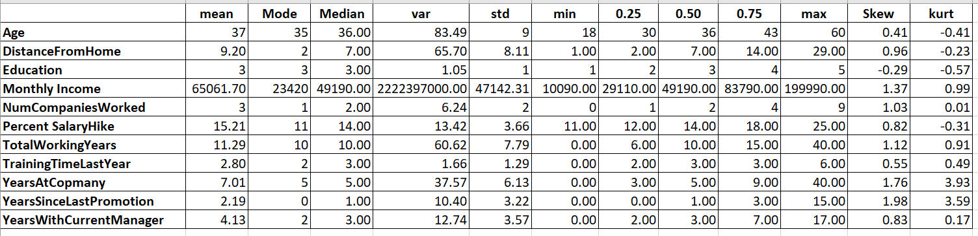

**Inference from the aboe data :**

* All the above variable except education show +ve Skewness. Interestingly Education level of the people showed negative skew implying company has more number of people who are just college and graduates passed people.
* Mean , mode and median all are close to 35 Years old, implying most of the people in the company are of the age group – 35 to 40.
* Mode of Total Years at company shows the people are likely to stay in the company for an average of 5 years.
* Mean Year since last promotion indicates at every 2 years once employees do get promoted in the Organization.
* Percent Salary Hike (75) – Indicates 75% of company staff gets upto 18% Annual hike.

**Outliers**

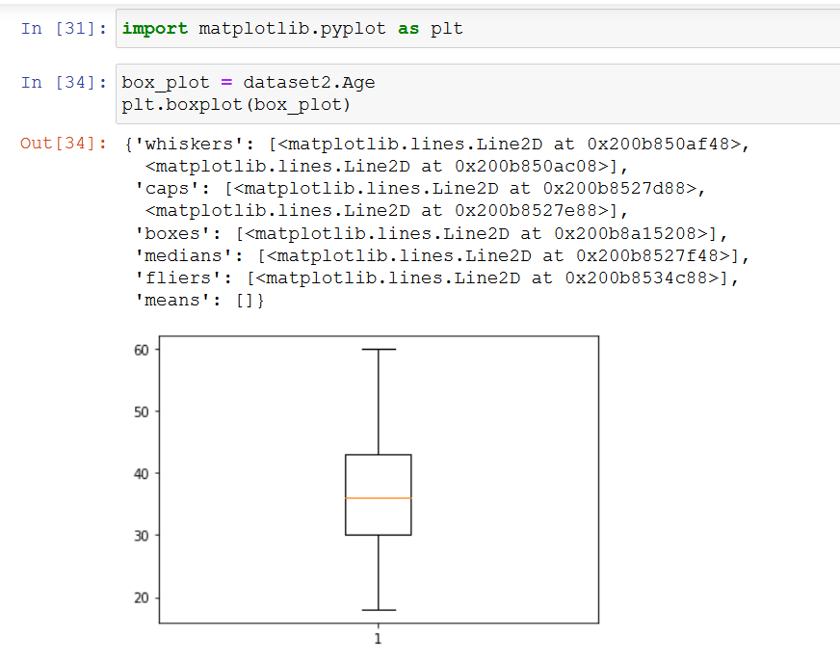

**Age is normally distributed without any outliers.**

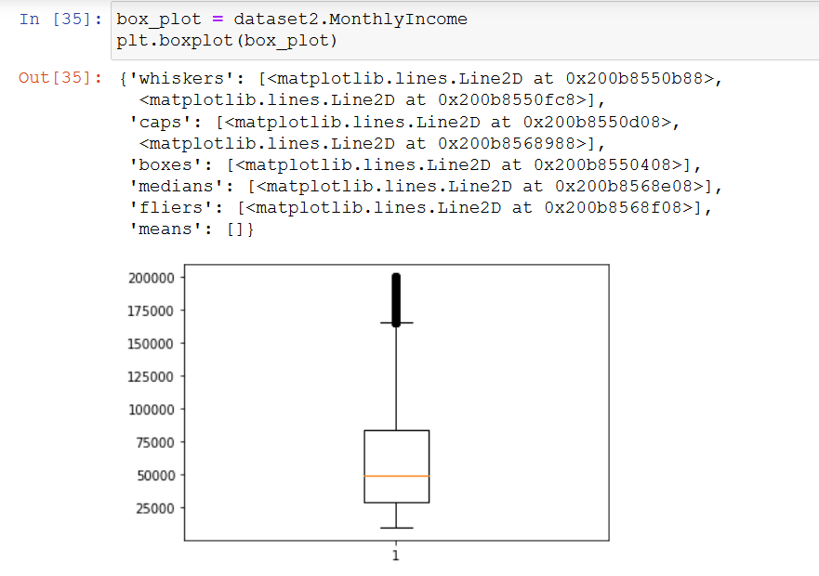

Monthly income has several outliers and it is right skewed.

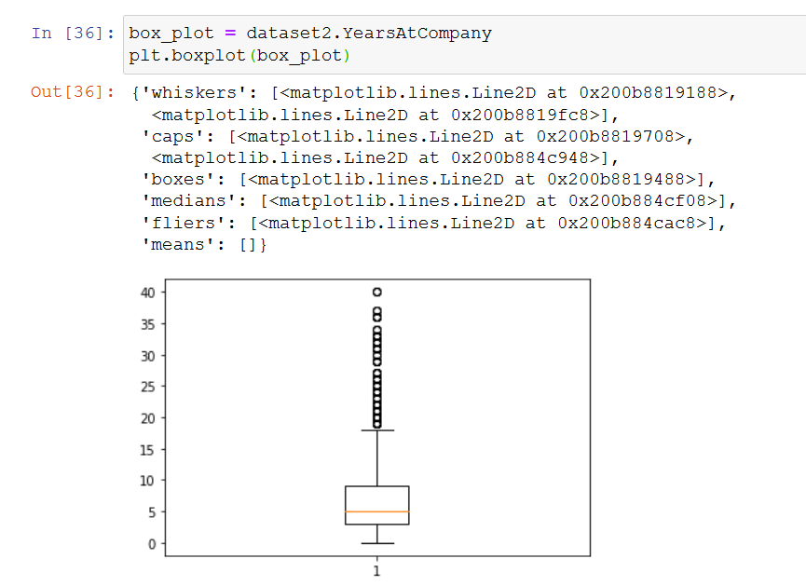

Years at Company is right skewed with several Outliers.

**Statistical Test:**

**Pearson test**

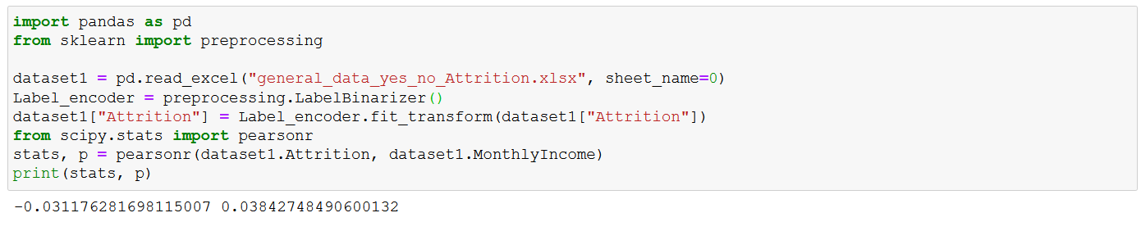

**Ho : There is no significance relation between monthly income and attrition**

**H1 : There is significance relation between monthly income and attrition**

**Since p value is less than 0.05, Ho is rejected.**

1. **Mann-Whiteny**

**Attrition Vs Distance from home**

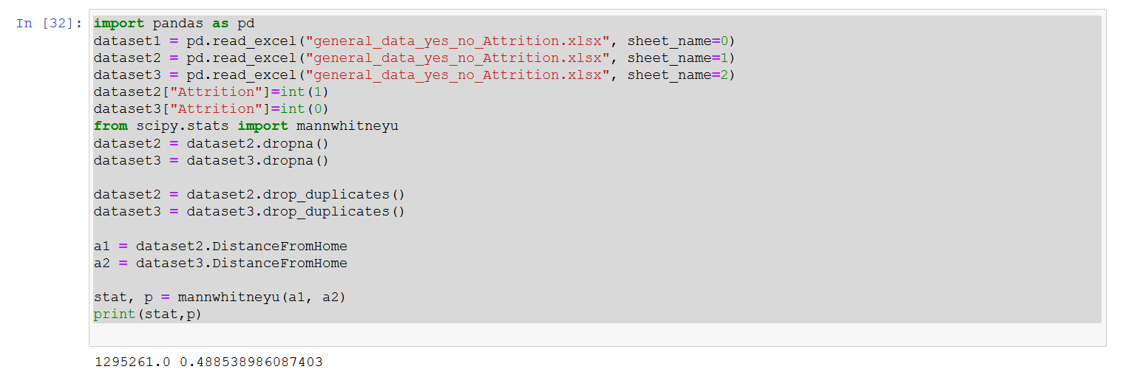

**Statistical Test I have not completed as I have not understood most of the test provided in the solution PDF document. Kindly request you to arrange a session to clarify the doubts on attrition project.**